**Syracuse Football Targeted Advertising Database**

Dorothy Fang, Samuel Bull

1. **Summary**

The sport of American Football has become what is known as “America’s Sport”, overtaking baseball for the top spot in the minds of Americans everywhere. College football has grown to be just as popular, and potentially just as much of a cash cow, as that of the professional leagues. College football team has been garnering fans and creating rivalries that are as old as some of the Universities themselves. On average, the teams of schools and universities for those in Division I Athletics bring in around $31 million dollars every single year[1]. For many schools around the country, it seems, football is the sport that makes them the most money and gives them the most recognition.

Since Governor Cuomo signed Executive Order No. 203.3 on March 12, 2020, suspending all gatherings of more than 50 people, Syracuse University Football has shifted its entire marketing strategy with an objective to upkeep its football game viewership. The objective is to retain those 40,000 fans that once packed the Carrier Dome while changing their modes of entertainment from in-person to online. How are Syracuse University Football and advertisers able to reach these fans that are segmented by age group, interest, location and behavior?

Currently Syracuse University football games are streamed by two networks, CBS sports and the ACC network under ESPN. These networks have made numerous carriage agreements with network providers such as Verizon Fios, Spectrum, AT&T, Hulu TV, YouTube TV, Playstation Vue, and Cuse TV. Customers with subscription plans with the previously mentioned network providers are able to stream Syracuse Football games on their devices like tablets, smartphones, televisions and laptops. Though viewers are accessing football games through the network providers, advertisements they are viewing are placed by networks. Currently, Syracuse Football and its networks are placing advertisements solely based on the viewer’s location. For example, placing an advertisement for Dinosaur BBQ for local Syracuse viewers while placing an advertisement for Inn-N-Out for viewers in California. The current solution lacks personalization and in depth segmentation of audiences because it disregards other variables that could influence the audiences’ experience. An example would be producing different advertisements based on the device an audience is viewing the game from. When a viewer is watching the game on a TV, laptop/desktop, or tablet he or she is most likely going to have a second device on hand. Thus, we can make an assumption that inputting a QR code in the advertisement for these devices will be effective. On the other hand, if a viewer is watching the game on a mobile phone, the QR code will not be effective due to the assumption that there will not be a second device on hand. By including more variables to differentiate viewers, we are trying to ensure that the ads run will prompt engagement for the companies we’re working with.

We propose building a new database that can store information from the network, network providers, advertising agencies, the actual advertisement, business and sponsors that allows advertisers to create more personalized ad experiences. It enables the cross referencing of data to derive insights. These insights can help advertisers place relevant advertisements in front of audiences based on their preferences and behaviors.

1. **Relational Data Model**

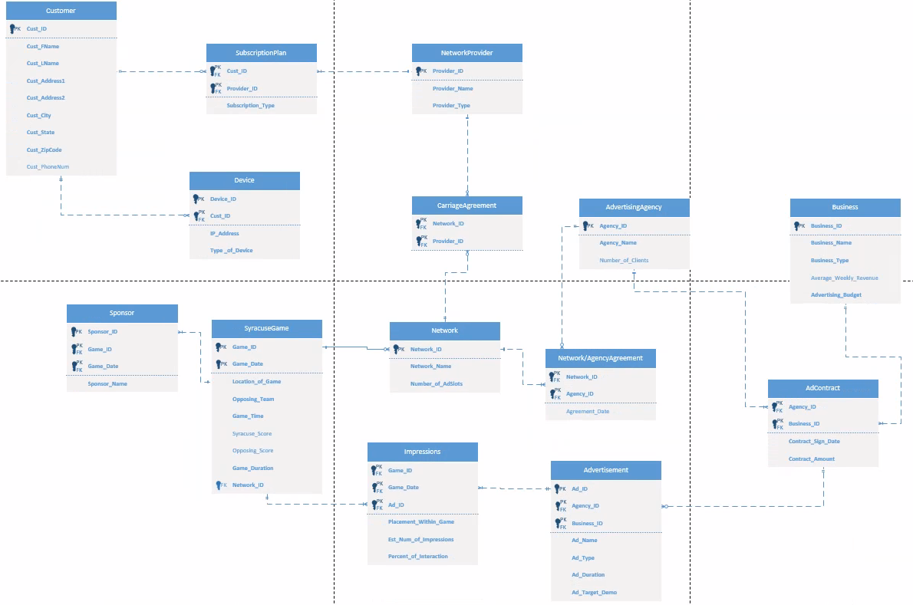

1. **Entity and Attribute Table**

|  |  |
| --- | --- |
| Customer | Stores information about the customer |
| Customer_ID | Primary Key. Unique to each customer. |
| Customer_First_Name | Required. |
| Customer_Last_Name | Required. |
| Customer_Address_  Number | Required. |
| Customer_Address_  Street | Required. |
| Customer_Address_  City | Required. |
| Customer_Address_  State | Not required because the customer can be in another country without a state. |
| Customer_Address_  Country | Required. |
| Customer_Address_  ZipCodePostalCode | Required. |
| Customer_PhoneNum |  |

|  |  |
| --- | --- |
| Devices | Stores information regarding the devices customers own. |
| Device_ID | Primary Key. Required. |
| Customer_ID | Primary Key and Foreign Key. Has a one-to-many identifying relationship with the customer entity. It refers to the business rule that one customer can only have three devices through one subscription. Required. |
| IP_Address | Required. |
| Type_of_Devices | Refers to the business rule that devices must be one of four option: of four options: television, smartphone, tablet, or laptop. Required. |

|  |  |
| --- | --- |
| Subscription_Plan | Stores information regarding the subscription plan the customer has chosen. |
| Customer_ID | Primary and Foreign Key. Has a zero-to-many identifying relationship with the customer entity. Required. |
| Provider_ID | Primary and Foreign Key. Has a one-to-many identifying relationship with the Network Provider entity. Required. |
| SubscriptionType | Required. It determines the number of advertisements placed during streaming. |

|  |  |
| --- | --- |
| Network Provider | Stores the information about the network provider. |
| Provider_ID | Primary Key. Required. |
| Provider_Name | Required. |
| Provider_Type | Required. Examples of providers are Verizon Fios, Spectrum, AT&T, Hulu TV, YouTube TV, Playstation Vue, or Cuse TV. Required. Determines which network provider the customer is accessing the game through. |

|  |  |
| --- | --- |
| Carriage Agreement | It is an associative entity towards network providers and the networks. It has two one-to-many identifying relationships with the Network Provider and Network entities. |
| Network_ID | Primary Key and Foreign Key. Required. |
| Provider_ID | Primary Key and Foreign Key. Required. |

|  |  |
| --- | --- |
| Network | Stores the information about the network. |
| Network_ID | Primary Key. |
| Network_Name | Required. Examples of networks are ACC Network or CBS Sports. |
| Number of Adslots | Required. |

|  |  |
| --- | --- |
| SyracuseGame | Description of the Syracuse Football Game. |
| Game_ID | Primary Key. Required. |
| Game_Date | Primary Key.Required. |
| Location_of_Game | Required. |
| Opposing_Team | Required. |
| Game_Time | Required. |
| Syracuse_Score |  |
| Opposing_Score |  |
| Game_Duration | Required. |
| Network_ID | Foreign Key. Establishes a one-to-many non-identifying relationship with the Network entity. |

|  |  |
| --- | --- |
| Sponsor | Description of the basic information of the sponsor. Different than advertisements. The sponsors have a placement at the physical game. |
| Sponsor_ID | Primary Key. |
| Game_ID | Primary Key and Foreign Key. Has a one-to-many identifying relationship with SyracuseGame. Required. |
| Game_Date | Primary Key and Foreign Key. Has a one-to-many identifying relationship with SyracuseGame. Required. |
| Sponsor_Name | Required. |

|  |  |
| --- | --- |
| Impressions | Associative Entity between Syracuse Game and Advertisement. Describes the KPI. |
| Game_ID | Primary Key and Foreign Key.Has a one-to-many identifying relationship with SyracuseGame. Required. |
| Game_Date | Primary Key and Foreign Key. Has a one-to-many identifying relationship with SyracuseGame. Required. |
| Ad_ID | Primary Key and Foreign Key. Has a one-to-many identifying relationship with Advertisement. Required. |
| Placement_within_Game | The timestamp of when the advertisement is place. For example, 00:20:30 which indicates 20 minutes and 30 seconds into the game. Required. |
| Est_Number_of_  Impressions | Required. |
| Percent of Interaction | Required. The percentage describes how many people interacted with the advertisement. |

|  |  |
| --- | --- |
| Advertisement | Description of the actual advertisement produced. |
| Ad_ID | Primary Key. |
| Agency_ID | Primary Key and Foreign Key. The agency that produces the advertisement. Has a one-to-many identifying relationship with Advertising Agency. |
| Business_ID | Primary Key and Foreign Key. The business that the advertisement is promoting. Has a one-to-many identifying relationship with Business. |
| Ad_Name | Required. |
| Ad_Type | Required. |
| Ad_Duration | Required. |

|  |  |
| --- | --- |
| Ad Contract | An associative entity between the advertisement, business and advertising agency entities. |
| Agency_ID | Primary Key and Foreign Key. Required. Has a one-to-many identifying relationship with Advertising Agency. |
| Business_ID | Primary Key and Foreign Key. Required. Has a one-to-many identifying relationship with Business. |
| Contract_Sign_Date | Required. |
| Contract_Amount |  |

|  |  |
| --- | --- |
| Business | The entity that describes the business putting out the advertisement. |
| Business ID | Primary Key. Required. |
| Business_Name | Required. |
| Business_Type | Required. |
| Averaage_Weekly_Revenue |  |
| Advertising_Budget | Relates to the business rule, “A company must have at least $5,000 invested in their advertising budget.” Required. |

|  |  |
| --- | --- |
| Advertising Agency | The entity that describes the ad agency that produces the advertisement. |
| Agency_ID | Primary Key. Required. |
| Agency_Name | Required. |
| Number_of Client |  |

|  |  |
| --- | --- |
| Network/Agency Agreement | An associative entity between network and advertising agency. |
| Network_ID | Primary Key and Foreign Key. Required |
| Agency_ID | Primary Key and Foreign Key. Required |
| Agreement_Date |  |

1. **Business Rules**

* A customer must be older than 18 to be logged.
* Network providers cannot interfere with streaming speeds based on the platform being used.
* Only three devices can be used while simultaneous streaming.
* A company must have at least $5,000 invested in their advertising budget.
* Devices must be one of four options: Television, Smart Phone, Tablet, or Laptop
* Only regular season games will be observed.
* Network Provider must be one of the following: Verizon Fios, Spectrum, AT&T, Hulu TV, YouTube TV, Playstation Vue, or Cuse TV.
* Over 20% of people who saw the ad need to interact with it for it to be considered a success.

1. **Data Questions**

* What ads are most effective when it comes to sales after the game? During the game?
  + What type of ads work the best?
* What companies are seeing the most business because of the ads?
* Which Network Provider sees the most viewers of Syracuse Football games?
* Do certain games see more business from the ads run? Do certain outcomes?
* Will the average consumer of Syracuse Football act upon seeing an ad? How long will it take?
* What devices are the most used to view the game? Do they contribute to sales?
* What is the average amount made by companies after a game? Is there a change during?

Research:

* <https://cuse.com/watch/purchase.aspx#register>
* <https://cuse.com/watch/purchase.aspx#register>
* <https://cuse.com/sports/2019/6/17/acc-network-faq.aspx>

1. Gaines, Cork. “The Average College Football Team Makes More Money than the next 35 College Sports Combined.” *Business Insider*, Business Insider, 5 Oct. 2017, www.businessinsider.com/college-sports-football-revenue-2017-10.